Week6_React Component Lifecycle

(blogapp)

Objective:
- Create a new react application using create-react-app tool with the name as “blogapp”
- Open the application using VS Code
- Create a new file named as Post.js in src folder with following properties

Phase 1: Setting Up Your Development Environment
Step 1: Install Node.js and npm
- Explanation: Node.js is a JavaScript runtime that lets you run JavaScript on your computer. npm is the package manager for Node.js, used to install and manage project dependencies like React.
- Action:
- Open a web browser and navigate to the official Node.js download page: https://nodejs.org/en/download/
Step 2: Install Visual Studio Code
- Explanation: Visual Studio Code (VS Code) is a free, powerful code editor that is highly recommended for React development.
- Action:
- Go to the official VS Code website: https://code.visualstudio.com/
- Download and run the installer for your operating system.
Step 3: Install create-react-app
- Open your command prompt (on Windows) or terminal (on macOS or Linux).
- Type the following command: npm install -g create-react-app
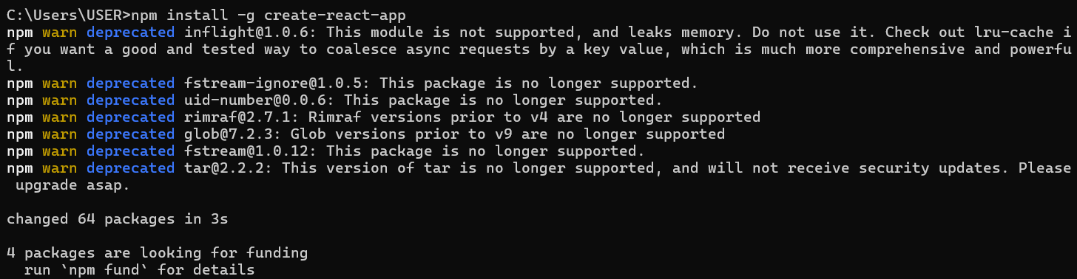

Phase 2: Creating and Running the React Application
Step 4: Create the React Application
- In your command prompt or terminal, navigate to the directory where you want to store your project (e.g., your Desktop or a development folder).
- Type the following command and press Enter. This may take a few minutes to complete.
create-react-app blogapp

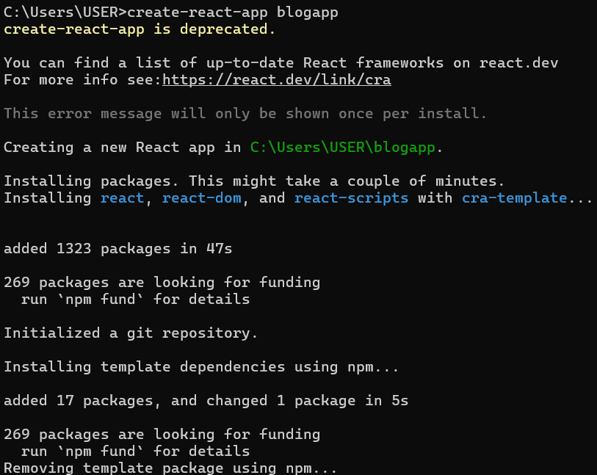
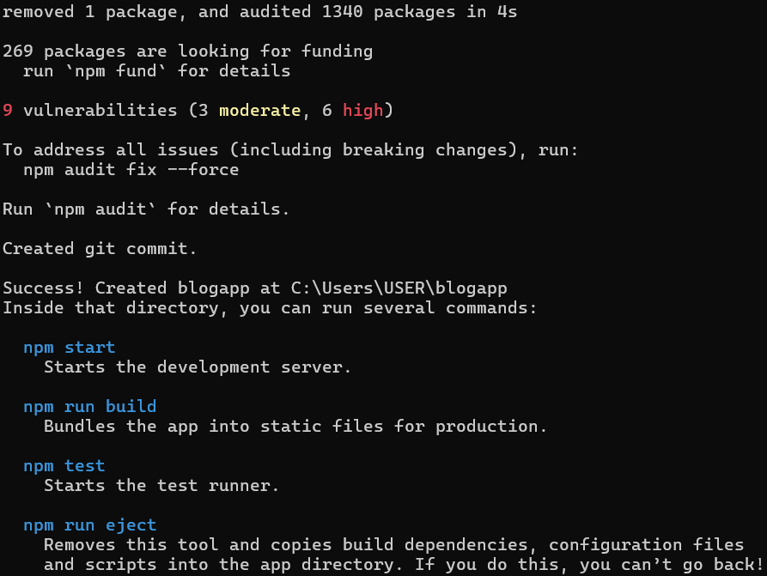

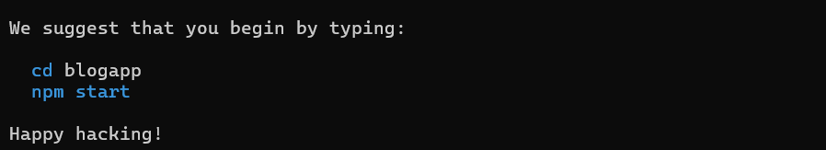
Step 5: Navigate into Your New Project Folder
- You must be inside the project folder to run commands related to this specific application.
- Once the command from Step 4 is finished, type the following command to move into the newly created directory:
cd blogapp
Step 6: Open the Project in Visual Studio Code
- This command opens the entire project folder in VS Code, allowing you to easily browse and edit the project files.
- While in the myfirstreact folder in your command prompt or terminal,
- Type the command:
code .
Note: The . tells VS Code to open the current directory.
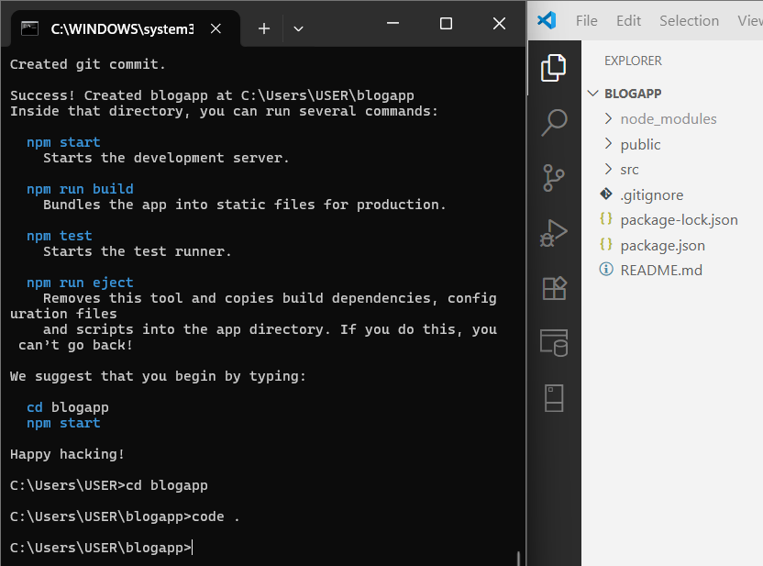
Step 7: Create the Post.js File
- In the VS Code explorer, right-click the src folder.
- Select "New File" and name it Post.js.
Step 8: Add Code to Post.js
import React from 'react';
class Post {
constructor(id, title, body) {
this.id = id;
this.title = title;
this.body = body;
}
}

// This is the React Class Component that will fetch and display data.
class Posts extends React.Component {
// 1. Initialize state in the constructor
constructor(props) {
super(props);
this.state = {
posts: [],
error: null
};
}

// 2. Create a method to fetch data from an API
async loadPosts() {
try {
const response = await fetch('https://jsonplaceholder.typicode.com/posts');
if (!response.ok) {
throw new Error(`HTTP error! status: ${response.status}`);
}
const data = await response.json();
// Update state with the fetched data
this.setState({ posts: data });
} catch (e) {
// If the fetch fails, update the state with the error
this.setState({ error: e });
}
}

// 3. Call the data-fetching method after the component mounts
componentDidMount() {
this.loadPosts();
}

// 4. Handle potential errors in child components
componentDidCatch(error, info) {
// You can log the error to an error reporting service
this.setState({ error });
console.error("Caught an error:", error, info);
alert(`An error occurred: ${error.message}`);
}

// 5. Render the UI based on the current state
render() {
const { posts, error } = this.state;
if (error) {
return <div>Error: {error.message}</div>;
}
if (posts.length === 0) {
return <div>Loading posts...</div>;
}
return (
<div>
<h1>Blog Posts</h1>
{posts.map(post => (
<article key={post.id} style={{ borderBottom: '1px solid #ccc', marginBottom: '20px', paddingBottom: '20px' }}>
<h2>{post.title}</h2>
<p>{post.body}</p>
</article>
))}
</div>
);
}
}
export default Posts;
Step 9: Edit the Main App.js File
- Open the App.js file from the src folder.
- Replace all of its content with this code:
import React from 'react';
import './App.css';
import Posts from './Post';
function App() {
return (
<div className="App">
<Posts />
</div>
);
}
export default App;
Step 10: Run the Application
- Go back to your terminal (it should still be in the blogApp folder).
- Run the start command:
npm start

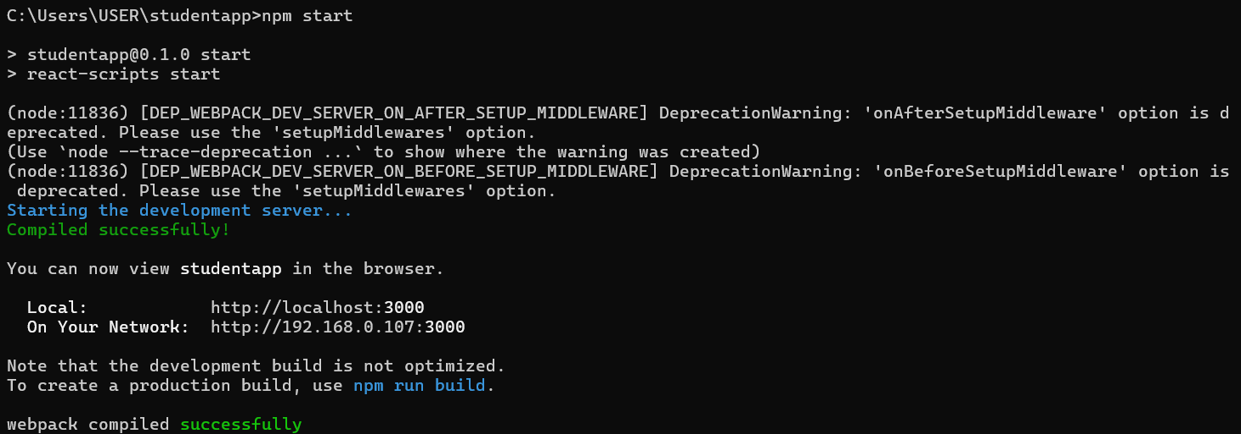
Step 11: View Your Application
- The development server hosts your application on a local port, typically 3000.
Local: http://localhost:3000
On Your Network: http://192.168.0.107:3000

Output:

